Judo for Children
There are several reasons parents choose martial arts for their children.
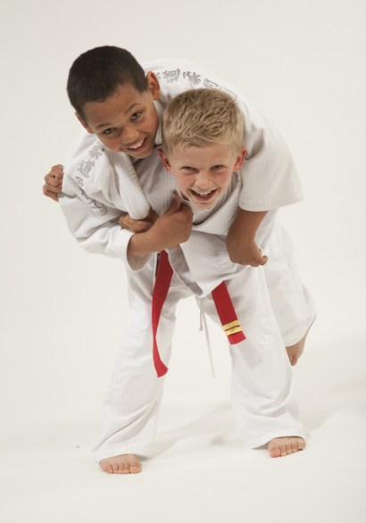
Judo is great for kids!
- To improve their focus and attention.
- To learn discipline.
- To have high self esteem or confidence.
- To protect against bullying.
- To increase focus.
- To be healthy and exercise.
- To try new activities.
We are confident our programs will benefit your children physically, mentally, and emotionally.
Judo: The safe and fun martial art for kids
Judo is an olympic sport, a means of physical education, a reliable system of self-defense, and a way of life. Judo is more than a “martial art,” it is a martial way. It develops its practitioners physically, emotionally, and spiritually by teaching respect and honor throughout sport. It literally means “the way of gentleness” in Japanese.
Judo is guided by three fundamental principles:
- Strive for perfection as a whole person (jika no kansei)
- Maximum efficiency, minimum effort (seiryoku zen’yō)
- Mutual welfare and benefit (jita kyōei)
These principles guide everything we do at Hui-O- Judo. Our goal is to develop each child in his or her individual goals and abilities and to help them reach their maximum potential in a positive environment.
We approach Judo in a safe, systematic way, ensuring that our instruction fits your child’s abilities and confidence level. Our program is not about winning or losing – it is about learning! We do not believe in pushing kids to their limit so that they can become “champs.” Instead, we help our youth learn by teaching proper techniques and body biomechanics. We also instill moral character and values.
What will my child learn in Judo?
Hui-O- Judo provides structured classes that are appropriate for your child’s age and skill level. Our youth classes start at age 6 and continue through age 15. Students age 14 and up may enter the adult class depending on their coordination and experience. Our classes are balanced between technique, free practice, physical fitness, and games.
Judo consists of getting into condition, learning to fall, throwing techniques, pins/grappling, control holds, and submissions (within age requirements). It does NOT involve striking, kicking, or the use of weapons. Your child will NOT be learning “how to fight,” instead they will learn how to play within a sport environment. Your child will learn valuable skills such as learning how to safely play with others in the sport, learning respect and discipline, and how to contribute to the team and community.
Hui-O- Judo’s classes also incorporate basic self-defense for kids. We make sure that your children will know how to avoid and prevent self-defense situations and know what to do when a situation cannot be avoided.
As part of our self-defense lessons, we also teach children how to respond to bullies. Hui-O- Judo’s approach is to teach nonviolent responses to bullying. We will teach your child to defend themselves against bullies, not become one.
The Benefits of Learning Judo
There are numerous benefits of practicing Judo. These include: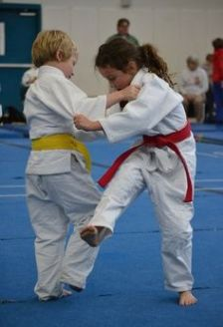
- Confidence
- Discipline
- Focus
- Commitment
- Compassion & Understanding
- Physical Fitness
- Respect of others
Unlike many other traditional martial arts classes, Judo kids actually participate in free practice, known as randori. All the techniques in Judo are fundamentally safe when practiced properly. Randori is a safe means of testing one’s skills against a resisting opponent. In many respects, this is a form of preparation for life’s many obstacles. Just as in life, we do not always have success, but there is always something to learn by winning and losing. By doing randori, students learn how to compete within the rules, develop persistence, resolve, and perseverance.
At its core, Judo develops good character. It teaches students how to face adversity and how to overcome it. It teaches children how to be polite and respectful of each other. As for the physical benefits, kids in Judo develop good strength and are less injury prone. The movements in Judo result in increased flexibility and balance.
Judo also instills good sportsmanship and discipline. Students learn how to work individually and with their team. At the beginning and end of a match, both contestants must bow to their opponent as a sign of respect. These acknowledgements signify their willingness to engage in a competition for each other’s benefit and to respect winning or losing/learning.
You can learn more about the benefits of Judo and how we structure our programs here.
Frequently Asked Questions about our Classes
- Is Judo safe for my child?
Yes. Judo does not involve striking, kicking, or the use of weapons. International studies have found Judo to be the safest sport for children 13 years old and under. It is also one of the top ten safest sports for children over 13 years of age.
2. Do I have to sign a contract?
No. Our membership options are month-to-month. We also offer family discounts. Please contact us for more details.
3. Are students required to compete in order to advance?
Competition is never required. Competition can be fun, but it may not be what your child wants. We encourage our students to explore competition, but while many of Hui-O- Judo’s students successfully compete in local, regional, state, and national tournaments, we are not a “competition only” club.

