A Parents Guide To Judo

Judo is an Olympic Sport that is practised by over 100 million people Worldwide in more than 200 Countries.
It is one of the highest participation sports in the World and is such a popular sport because of its philosophical and cultural roots as well as its educational base.
Judo offers a safe and challenging environment in which students can achieve both physical and spiritual levels that can not only change the course of their lives but direct them to bigger and better things.
The name ‘Ju Do’ literally translated means ‘Gentle Way’ and when JigoroKano developed the sport of Judo or educational purposes at the turn of the20th Century his main objective was to create a learning process that would benefit all ages and all levels of student.
Judo is a sport that can be developed to Olympic participation but it is also a discipline, a recreational past time and a way of life.

The History Of Judo

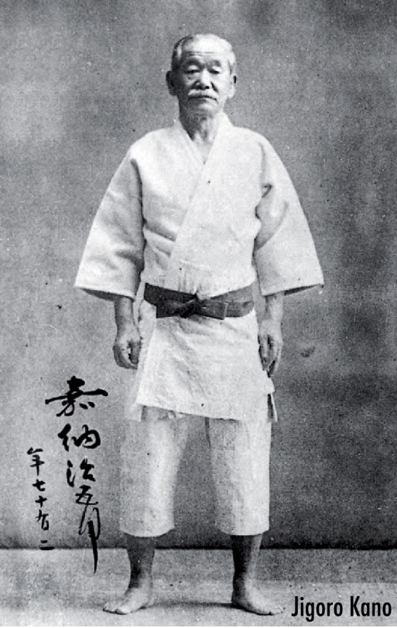
Judo, meaning “gentle way,’ is a popular and venerable Japanese martial art that has spread in popularity so far as to become an Olympic sport.
The main objective of the martial art is to pin an opponent to the ground or force a submission by applying a chokehold or joint lock.
The three main techniques involved in modern Judo are throwing techniques or nagewaza, or katame-waza which are techniques in ground work .
Submission holds are only allowed in senior Judo and not at Junior U16 years old.
Jigoro Kano was born into an affluent family as the son of a head priest in 1860. Even though Kano was good at his lessons, he constantly worried about his weak physique and the bullies who used to give him a tough time. He decided to learn jujitsu but had difficulty finding a good trainer.Most people who knew the art were not enthusiastic to pass them on as they considered them useless.
Finally, he started training with Yanosuke Fukuda, a jujitsu master at a school. He grew so passionate about martial arts training that at the age of just 21, he started a new school to teach a new martial art called Judo, consisting of some of the best moves of several prominent jujitsu styles and made safe enough to put into the Japanese school curriculum.
This was the birth of Judo!
In late nineteenth century, Kano travelled to Europe to spread Judo outside Japan. Kato tirelessly worked to spread Judo across the globe, even while serving in the Olympic Committee. It was a dream come true moment for Kano when men’s Judo was officially announced as an Olympic event in 1964 Tokyo Olympics but only for men.
At the 1988 Seoul Olympics women’s Judo was introduced as an exhibition sport and later Barcelona four years later.
At present, more than 200 countries have registered as members of the International Judo Federation.
The art and sport of Judo is being promoted Worldwide as a truly International sport. Every year it grows in stature and attracts people of all ages and abilities to participate in our art.
A Judo club has to be registered with a recognized governing body that is insured and governed by a National Sports council. All participants of the club are registered and insured for all levels of Judo practice. This will give each participant the benefit of the clubs membership services. The club has to offer a safe working environment with a sufficient matted area, enough qualified staff to cope with the numbers in the class and protect the students from any form of negligence, harassment and abuse.
A club should be a welcoming environment that follow the traditional rules of the Dojo. These are in place for safety, hygiene and to ensure a positive and progressive place to practice.

Etiquette
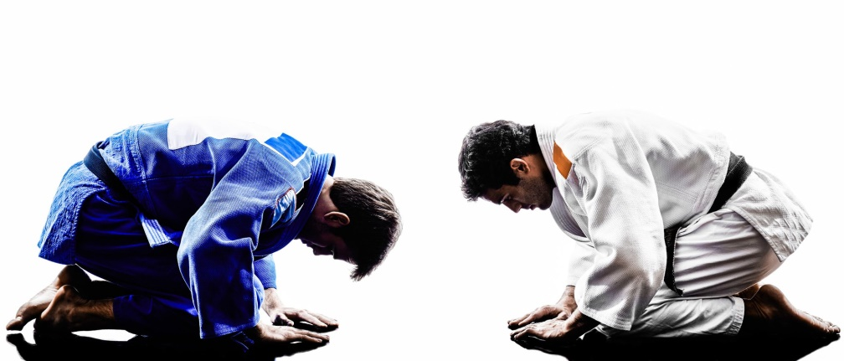

​Bowing
- ​Bow when entering or leaving the Dojo.
- Bow when stepping on or off the mat.
- Instructors and students bow to each other, in mutual respect, at the opening and closing of class, working together & competitive match.
- Bow to every partner you are paired with. It is a way of thanking them for helping you to become a better student and thanking them for working with you.
- Bow when accepting an award, taking the award with both hands as you bow.
- Bow to a SENSEI as he or she enters the Dojo.
- Bow whenever you wish to give a demonstration of respect. It’s like a handshake!
- Bows should be performed with Respect and Humility.
- They should be slow and measured and never hurried.

Safety and Hygiene
- Make sure the mat is safe to train on.
- Never leave the Dojo without receiving permission from the instructor.
- No food, drink or chewing of gum are allowed on the mat.
- No non-judo activity is to take place during class time.
- Report all injuries to the instructor immediately.
- When arriving at class with an injury, the instructor must be notified prior to the start of class.
- Shoes are NEVER to be worn on the mat.
- However, you should have something on your feet [i.e. shoes, sandals] anytime you are off the mat.
- No jewellery or metal ornaments shall be worn during class
- ​Finger and toenails are to be kept clean and trimmed to a reasonable length.
- Water bottles are permitted in designated area at mat-side.
- Water bottles are to have water or electrolyte beverages only.
- Never come to class under the influence of illicit drugs or alcohol.
- Members are to keep their Gis clean and in good repair. No holes or tears.
- Spills are to be cleaned immediately.
- Rubbish should be placed in the proper container.
- Blood must be cleaned up immediately using proper procedures and materials.
- No practising of judo skills and techniques is allowed without permission of the instructor

Etiquette and Protocol
- ​Always Show Respect
- Always address the teacher/coach/ Instructor as SENSEI.
- Show respect to instructors and higher belts at all times.
- New students and guests should always have a partner to work with.
- Students are expected to sit in proper fashion when resting or listening to an instructor.
- Seek to help each other.
- Be responsible for your safety and that of others.
- Higher-ranking students are to help lower ranking students adhere to all matters of protocol and etiquette.
- Never talk while the instruction is taking place.
- Never talk while in line-up. Stand still.
- Arrive at class on time.
- Never leave the mat or Dojo without the permission of the instructor.
- Always be courteous. Hot tempers or offensive language are not permitted and will not be tolerated.
- Always try hard to improve your level. If you are late to class, wait for a SENSEI to give you permission to join the class.
- Always treat your fellow judo players with respect and dignity

Behaviour Outside The Dojo
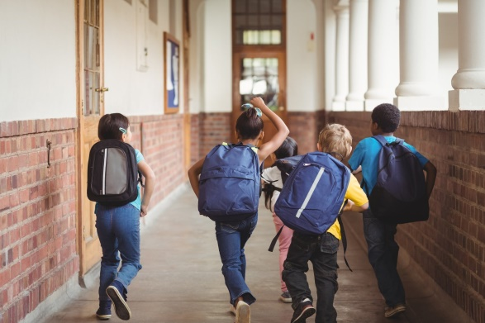
Behave in a matter that will bring Respect and Honour to the club.
Judo is to be only practised in the DOJO under the guidance of a qualified Judo Instructor.
Your Judo skills should never be used outside of the DOJO. Do not attempt to impress your friends with your judo skills.
Do not demonstrate judo in public unless it is part of a club activity or unless you have received prior permission from your Judo Instructor.
Judo techniques should not be taught to anyone unless they are under the guidance of a qualified Judo Instructor.
Any club member who encourages an altercation between others will be dismissed

Behaviour When Visiting Another Club
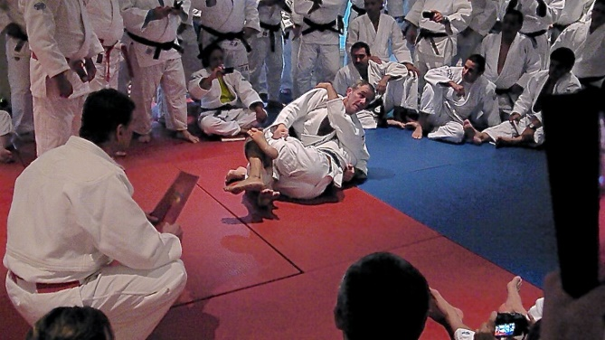
You Represent your Judo Club
Behave in a matter that will bring Respect and Honour to your Judo Club
Remove your shoes before entering a Dojo.
Introduce yourself and ask permission from the instructor to participate in class before changing into your Gi.
Be attentive.
Never argue or disagree with the way techniques are taught or presented.
Do not show off.
Make sure you follow the Club Rules and Regulations at all times
Follow the rules and regulations of the Dojo you are visiting.
Always thank the club members you worked with for sharing and working with you.
Thank the instructor[s] for allowing you to participate.

What to expect from a Judo Coach or Instructor
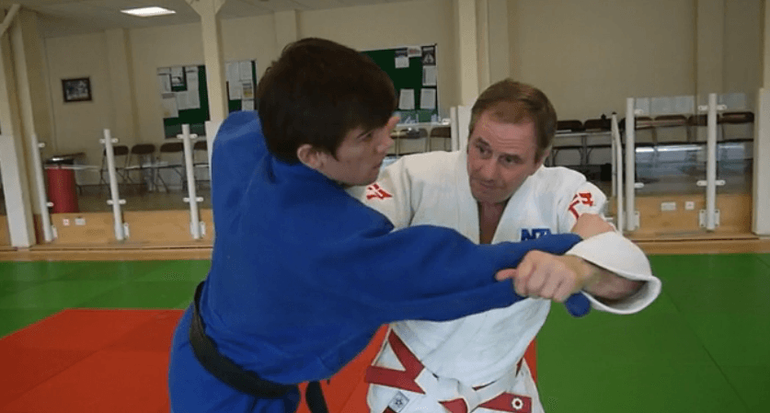
We always have a teacher or an Instructor that we remember who has influenced us in what we do. They help us to achieve things that we would not normally be able to achieve.
They are someone who has taken their time to structure and present their class in a constructive and interesting way.
Their attention to technical detail is paramount and they demonstrate a sound understanding of safety and etiquette within the sport.You should make sure that they have a Nationally recognised coaching certificate and that the coaching body is recognised by the Sports Funding body.
Unfortunately, there are unethical Martial Arts Organizations and Grades (Belts ) in all Martial Arts and so special attention must be paid to how they teach, how much your child is taking away with them

What Is Expected From The Judo Parents
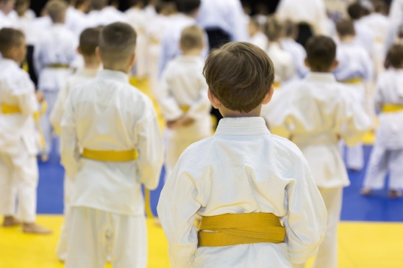
Without the parent’s help and support many budding Judo stars would never be able to start their quest for Judo excellence. Parent’s are essential to the process of developing young talent.
A parent is not only the backbone of the process but also becomes the funding agent and the taxi driver as well. Parent support is absolutely essential but parents have to remember that there are very thin lines between supporting, wanting them to do their best, and pushing your child. It is also a contact sport, so accidents will happen, as will bumps and bruises. What we don’t want is to lose active children at youth level simply because too much pressure was put on them to win and at all costs. Parental pressures can have an adverse effect on the child and their ambitions to succeed if too much pressure is placed on the kids.
Do not underestimate your impact on your child's experience on and off the mat. They look to you for the encouragement, and that validation and yes, enjoyment!
If you are enjoying it, they will most likely enjoy it too.
Involvement with your club helps everyone. Your child sees the support your land that gives validation to their choice. It also helps the club with another set of helping hands, especially if you have a specific skillset.
If you are a marketer, computer whiz, doctor or accountant, these are all essential jobs that each club has, so volunteering is also a way of supporting. It is very common that once a child starts in Judo, the parent follows on to the mat.
It is a means to great whole-body fitness and wellness, as well as a stress reliever and community orientated sport. You can do Judo anywhere in the World!
The belt is a signification of skill level consisting of specific sets of technical skills that must be performed to a high standard. A grading is like any other exam found in school or other skill-based interests.
The beginner belt is a white belt and sometimes red, if the judoka is under 8years of age (or competition age)* . The traditional progression is White, Yellow, Orange, Green, Blue, Brown, Black.
The colors are progressively darker as traditionally when a Judoka earned their next grade, they would dye their belt the next darker color. It is important to study the techniques to a high standard as these are the foundations of the Art & Sport of Judo and will create a more adaptable Judoka as they progress through the years.
It is important for parents to familiarize themselves with the techniques as this makes it more enjoyable for both the parent and child.
Learning the terminology, rules, scoring and technique names gives a common platform
For parents who are looking to help their children to succeed in Judo, our online resources can help a child to understand exactly how to perform every technique.

