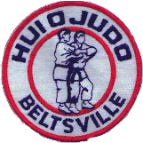
Hui-O-Judo Beltsville

Welcome to Judo

This is my First Judo Class
First off let us start by saying, welcome to the club! For both parents and students, there are no dumb questions, the only dumb questions are the ones not asked. So if you have questions, please, just ask!
If your new to judo or the martial arts in general, we suggest you first check out our webpage (Hui-O-Judo). If you read thru this pamphlet it may answer many of your questions about what judo is, and what you will learn in our class.

What is judo about?
Judo is Japans Gentle magic. “Ju” means gentle and “do” means way. We want you to enjoy the experience of learning judo. We teach judo to build character in each person. By making each person better, will make our world better. The ultimate aim of judo is self perfection. You should work every day to improve yourself on many levels. Judo is a system of training the body and mind to work in harmonious perfection. Judo teaches the use of your partners force and momentum to perfrom your techniques.

What are the instructors names?

Sensei Kevin Tamai – Head Instructor – 6th degree
Sensei Diane Jackson – 5th degree
Sensei Peggy Whilden – 6th degree
Sensei William Bradley Mason – 3rd degree
Sensei Reza Bizaran – 3rd degree
Sensei Margie Kettl – 3rd degree
Sensei Brandon Viernas - 1st degree
Sensei Chris Howell – 1st degree
Sensei Shaun Eddy – 1st degree
Sensei R.Wayne Brown – 1st degree
Sensei Andrew Furjanic – 1st degree
Sensei Brian Lopez – 1st degree
Sensei Tyler Smith – 1st degree

Are my instructors trained and certified?

Yes, all of the teachers (sensei) are trained and certified by the national governing body of judo – USA Judo Inc. They have been through certification courses. Each one also has to go thru and pass a background check and first aid/CPR/AED training. Most have been practicing judo their entire lives.

How old do I have to be to join the club?
We request that aspiring young members who wish to join be preferably 6+ years old (Possible acceptations aside). We find that students younger then this do not always have the attention span nor required coordination skills yet to perform judo safely and get the full benefits of the class. Although judo may be a fun activity please understand it is not "supervised play". If you have any questions, please feel free to contact one of our instructors.

What should I wear to class?
We recommend sweat pants, and a long sleeve sweatshirt. Judo is a "grappling" martial art so, you need something to grab hold of to control your opponent, this is why long sleeve shirts are a must. Girls should have a PLAIN WHITE T-SHIRT underneath their sweatshirt; and sports bra when appropriate. Keep in mind, grabbing and pulling will be done, so it's best that it not be your most "new" outfit.
If you've been in the martial arts before you may already have a gi (uniform), this is fine but we also suggest that you wear sweats. Uniforms typical of other arts like karate are extremely thin and will not withstand the pulling and tugging needed for a judo workout. If you have rank in another art other then judo, please tell us; but out of respect do not wear another arts colored rank to class, use your white belt, please.
Bring something like sandals or slippers you can easily slip on and off your feet to walk off the mat; for going to the bathroom, and getting dinks for breaks; we keep our mats as clean as possible.

What if I want to do judo, but am blind or have very bad vision?
Depending on your physical abilities, there is no reason why you can't (doctors permission of course); as judo is officially an Olympic sport and Paralympic event. With it's own set of rules regarding deaf and or blind competitors. Judo is recognized as one of THE BEST martial arts worldwide for such individuals.
If you have an interest in visually disabled judo, or know a friend that may want to try it, please contact us!

Do I need to buy a Judo-Gi (Judo Uniform) right away?
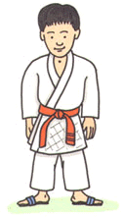
NO, this is not required. In fact we suggest you not invest in one until you finish our 8-Week beginners class. The judo uniform is an investment. The gi's we typically sell range in price from $30 to $60 depending on size and type. A typical child's gi we sell is around $40 new. The judo uniform you buy now can last you a LONG time. In fact most younger kids outgrow a gi before it is worn out, so ask us about good condition, used uniforms as well.
When getting dressed for class girls should have a PLAIN WHITE T-SHIRT or LEOTARD underneath their uniform (IJF Rules); and sports bra when appropriate. Boys by tradition do not wear any shirt under the gi, but we allow shirts at the dojo if you wish. In tournament play shirts for boys / men is not permitted.
Bring something like sandals or slippers you can easily slip on and off your feet to walk off the mat; for going to the bathroom, and getting dinks for breaks; we keep our mats as clean as possible.
Donated / Used Uniforms
If you have an old judo uniform you no longer wear, or it just won't fit and it is not a total loss, consider donating it back to the club so we may use it when beginners start learning how to throw in class. Parents of students, if your child has out grown there gi, or has quit class and the uniform still has a good life left, let us know and we (or you) can donate it back to new younger or smaller student. (Remember to wash the uniform first please!)

What's with the Blue or White uniforms I see?
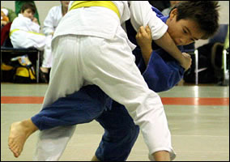
The blue judo uniforms hold no status, and mean nothing. In a judo competition the first name called to fight will wear a blue sash or belt, and the second name will wear a white sash or belt.
Higher level tournaments (Nationals) go one step further and make the first name called wear an entire blue uniform, second name a white uniform. This makes it very simple for officials, and spectators to tell who's who on the mat.
For more information on this subject, please see your instructor.
Beginners should always buy a WHITE uniform first.

All this falling stuff looks like it may hurt? Is judo really safe?
Judo is VERY safe, in fact that was the intention of Dr Kano when he invented judo, to make it safer than most other martial arts. The American College of Sports Medicine, says JUDO is the safest contact sport for children under the age of 13 played in the United States.
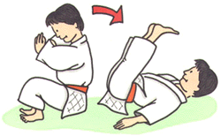
ALL beginners learn how to FALL PROPERLY before they ever do any kind of judo throwing. (You need to crawl before you walk.) This training is called Ukemi (Brake-fall). Through these drills you learn to relax your body and expel the air from your lungs as you hit, and spread the force of the fall out, this keeps you safe. Because these drills are practiced every day in judo class they become second-nature.
Judo falls can also save your life and prevent injury outside of the dojo as well, they are not a judo only technique. Learning not to stop a fall with your hands and wrists can greatly reduce or even prevent injury. For example, slipping on ice in winter, or someone tripping you in school.

What is the class progression, what will I learn?
Over our 8 week beginners class time frame you will learn...
- Short history of judo, who founded it, what judo is, and LOTS of judo terminology.
- You will learn how to FALL properly. (Judo is a throwing and grappling art)
  - Backward Brake-fall → Right & Left Backward Brake-fall (Brake-fall is called Ukemi)
Back Fall
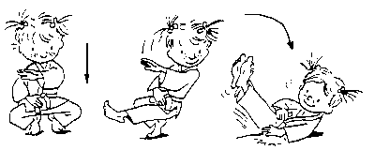
Side Fall (Left and Right) Yoko Ukemi
- Judo dojo rules and mat safety.
- You will learn the Rolling Brake-fall. - Zempo-kaiten: "Forward Rolling Fall"
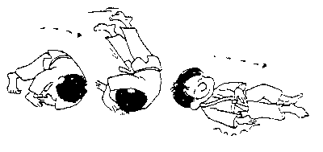
  - Tumbling Skills → Somersaults→ Ground Rolling Fall → Standing Rolling Fall
- You will learn your first judo hold-down. - (Hon) Kesa Gatame: "(Normal) Scarf Hold"
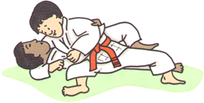
- You will learn Tai Sabaki - "Turning Movements" (Harder then you think!)
- You will learn your first judo throw. - O-Goshi: "Major Hip Throw"
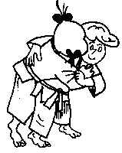

- You will learn your second judo hold-down. - Yoko Shiho Gatame: "Side Locking Four-Corner Hold"
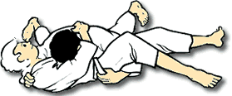

- You will learn your second judo throw. - O Soto Gari: "Major Outer Reaping"
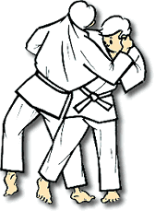
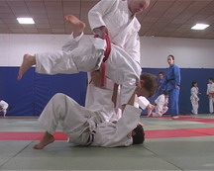
We do like to keep class FUN, so we do play some games and have hints and tips along the way. Typically after the first weeks' class (all the falling drills) things start to pick up and we do a lot more fun things. This is only a short list of what we do in a typical beginners class. If you have any questions, feel free to ask one of our instructors.
The Kodokan Judo Syllabus has Ukemi (Brake-Fall Techniques), 15 Kata's (Set Forms), a total of 67 official Nage-Waza (Throwing Techniques), 29 official Katame-Waza (Grappling Techniques) along with 22 Atemi-Waza (Striking Techniques) for Self-Defense and Kata. It can take several years to learn them all and a lifetime to master.

My child does not seem to do or understand _____ properly?
Please understand that it can take time for a child to understand the exercises, rolls and movements we try to show them. Our instructors are very diligent and see the mistakes they make, but may not always correct them immediately. We want class to be FUN and we don't want to discourage them. This awkwardness tends to works it's way out after about the 2nd or 3rd week of class.
Most notably we find that many students have trouble with Tumbling Skills and Summersaults. You can help us if you wish by showing your child how to perform a simple somersault (head-over-heels roll) at home in a safe environment. We want every one to succeed no matter what there ability. We value you and your child's input, so please talk with one of our instructors if you have any questions, we are here to help. We can always take the time for 1 on 1 instruction if the need arises.

What's the language you speak during class?
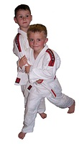
Judo terms and other things related to the art are spoken in Japanese. We do this to show respect for the art and it's founder who was Japanese. Japanese is the "universal language" of judo and no matter where you go in the world the terminology will be the same; meaning, no matter if your in Europe, Mexico, South America, or Russia … judo terms are still taught in Japanese!
A few words:
- Dojo – place to practice - Exercise Hall
- Tatami - Mat
- Judo - Gentle Way (The Way of Gentleness)
- Judoka - A person who studies Judo
- Judo-Gi - Judo Uniform
- Sato - Student
- Sensei - Teacher
- Sempai - Assistant Teacher, typically the highest ranking student of the club, not yet a black belt.
- Seiza - Kneeling Posture
- Anza - Cross-legged Sitting / Indian Style
- Hajime - Begin
- Matte - Stop
Counting in Japanese:
1 | 2 | 3 | 4 | 5 | 6 | 7 | 8 | 9 | 10
Ichi | Ni | San | Shi | Go | Roku | Shichi | Hachi | Ku | Ju
11 | 12 | 13 | 14 | 15 | 16 | 17 | 18 | 19 | 20
Ju-Icha | Ju-Ni | Ju-San | Ju-Shi | Ju-Go | Ju-Roku | Ju-Shichi | Ju-Hachi | Ju-Ku | Ni-Ju
A more complete list of terms is available from the sensei. Knowledge of terms is not strongly required by beginners, but we ask that you pay attention and try to learn them. Terminology IS a requirement for rank promotion.

What happens after the 8 week beginner judo program?
We hope to have instilled a love for judo in the first 8 weeks you have been with us. We hope that you will continue to study judo. After you complete the 8 week beginner program, you can sign up for the intermediate class. The class is twice a week, however many still come just once a week. You will need to purchase a gi. You can purchase your own or see sensei Kevin to get one. They are about $35. You will also need to sign up for membership in the United States Judo Federation. The cost is $70 for one year membership. If you have studied and feel that you have a good grasp on what you have learned, you can ask sensei about getting tested for promotion to your next rank. Remember judo is about character and spirit, not just knowledge or skills.

What are the belt colors (ranks) in judo?
In our judo club, juniors are promoted with stripes and solid color belts. The stripes are called "Mon" and reflect the 1/2 rank between the solid colors. Senior adult students (17+) are promoted traditional Japanese style with White, Brown, Black (no stripes).
* Minimum age requirements are guide lines only.
# | Aprox. Min. Age | Color | English | Japanese
11th Kyu | 5 Years Old |  | 6th Grade | Ro-kyu
10th kyu | 6 years old | Advanced Rokkyu -White + Yellow Striped belt
9th Kyu | 7 Years Old | Yellow | 5th Grade | Go-kyu
8th kyu | 8 years old | Advanced Gokyu - Yellow + Orange Striped belt
7th Kyu | 9 Years Old | Orange | 4th Grade | Yan-kyu
6th kyu | 10 Years Old | Advanced Yonkyu - Orange + Green Striped belt
5th Kyu | 11 Years Old | Green | 3rd Grade | San-kyu
4th kyu | 12 Years Old | Advanced Sankyu - Green + Blue Striped belt
3rd Kyu | 13 Years Old | Blue | 2nd Grade | Ni-kyu
2nd kyu | 14 Years Old | Advanced Nikyu - Blue + Purple Striped belt
1st Kyu | 15 Years Old | Purple | 1st Grade | Ik-kyu
1st Dan |  | Black | 1st Degree | Shodan
2nd Dan |  | Black | 2nd Degree | Ni-dan
3rd Dan |  | Black | 3rd Degree | San-dan
4th Dan |  | Black | 4th Degree | Yo-dan
5th Dan |  | Black | 5th Degree | Go-dan
6th Dan |  | Red & White | 6th Degree | Roku-dan
7th Dan |  | Red & White | 7th Degree | Shichi-dan
8th Dan |  | Red & White | 8th Degree | Hachi-dan
9th Dan |  | Red | 9th Degree | Ku-dan
10th Dan |  | Double Wide White or Red | 10th Degree | Ju-dan
* There have only been 15 10th Dan ranks awarded by the Kodokan to date. Profiles of Kodokan 10th Dan Holders.
* Mrs. Keiko Fukuda 9th Dan at the age of 88, makes her the highest ranked and oldest woman in judo. (Born, April 12, 1913 - Died, February 9, 2013) She taught at the Soko Joshi Judo Club in the Noe Valley District of San Francisco, CA.
* In Joshi or Woman's Judo, persons who hold a black belt rank are awarded a special black belt that has a white stripe down the center. This belt is only awarded to woman. And represents the Pure form of Judo as they do not rely on strength like most men do. However most woman prefer a normal black belt like men.
11th Dan † |  |  | 11th Degree | Ju-icha-dan
12th Dan † |  |  | 12th Degree | Ju-ni-dan
† Only Dr. Jigoro Kano him self was awarded the 11th and 12th Dan ranks. They where awarded after his death by order of the Kodokan and Japanese Government. He was also awarded the title of Shihan.
Most black belts will wear a normal black belt most of the time, some may have stripes (rank tabs) or not, it is a personal preference at this level. Master Kano was fond of a normal back belt for class; and in fact most black belts will wear the same belt threw out there career so much so that it becomes white with age. This is why the 10th dan is symbolically a white belt. It symbolizes "Full Circle" White to Black and then back to White.

How do I get promoted, when will I get my black belt?
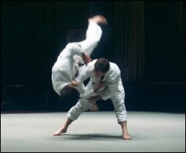
Students are ranked according to SKILL and KNOWLEDGE of judo, that grade being reflected in the color of the belt. We try not to focus everything in emphases on "Belt Color", the "belt" is only as good as the one who wears it.
With that being said unlike other westernized and commercialized martial arts like some ´karate businesses´ more commonly referred to as McDojo's; where they say you may get your black belt in a year or two, this is simply not true in judo.
In fact the youngest you are even eligible to have a black belt in judo is 17 years old in the US. This is extremely rare. In Japan there is no such thing as a Junior Black Belt. There are always rare exceptions to this rule. (National Judo Champion, fighting adults of dan grade and winning "Batsugan", or simultaneous promotion; extremely rare.)
What Does a Black Belt Really Mean? -
There are two divisions of grades, the student grades (Kyu), and the master grades (Dan). In the west, the kyu colors run from white (a rank beginner) then through yellow, orange, green, blue, purple for juniors under 17. The colors change slightly for seniors of 18 years old or older, in that blue and purple are replaced by brown. In Japan, all kyu grades wear white for ranks 6 to 4 and brown for 3 to 1st kyu. So in Japan, there are only 2 colors of student rank, white and brown! Student ranks go backwards from 6th kyu to 1st kyu; black bells of course go forward from 1st dan to 10th dan. Jigoro Kano (founder of Judo) was the inventor of the kyu - dan grading system, that soon got adapted by other martial arts such as karate.
In our judo club, you are eligible (but not guaranteed) to receive your White Belt + Yellow Stripe after completing our beginners class and after being in judo for about 3 months. To receive your Yellow Belt, we require you be in judo at least 6 months (after promotion) and have attended at least one judo tournament. The USJI , USJA, and USJF set requirements that must be fallowed for promotion, they can be interpreted on a per-club basis. You will be notified if you are eligible for promotion by one of our instructors, and what needs to be done to get promoted.
A black belt is not something you "Get", it's something you EARN.
"Train hard, be humble, don't show off or complain, and do your best in everything in your life. This is what it means to be a black belt. Black belts are often ordinary people who try harder and don't give up. Black belt can be achieved in spite of any weaknesses you may have. I have promoted men and women who began training very late in life, people who were disabled or blind, and people who were very afraid of physical activity when they started. It is how you face and overcome your own personal difficulties that determines your character, an important component of a black belt." ~ Neil Ohlenkamp, 6th Dan

What are the "Official" rank requirements?
As mentioned all rank promotions can be interpretod on a per-club basis and always at senseis discretion. But there are official guide lines that are fallowed, rank is never just handed out. Above all, class attendance, attitude during class and later tournament performance, play a very important role in promotion. You are tested every day in class, by remembering terms and the names of the throws we go over in class so always do your best.
The information can be confusing, so if you have any questions, please contact one of our instructors. Promotion to your next rank is not something you should worry or stress over, you will get your rank when the time is right for YOU.

What is next?
Start your judo journey. We hope that it will be a lifelong journey you will love. Ask questions and improve yourself every day.

